Regulations:
A18

H.T No

Sreenidhi Institute of Science and Technology
(An Autonomous Institution)
Code No: 7K301 Date: 14-Dec-2019 (FN)

B.Tech II-Year I-Semester External Examination, Dec-2019/Jan-2020 (Regular)
INTRODUCTION TO SOLID MECHANICS (CIVIL)

Time: 3 Hours Max.Marks:70

Note: a) No additional answer sheets will be provided.
b) All sub-parts of a question must be answered at one place only, otherwise it will not be valued.
c) Missing data can be assumed suitably.

Part - A Max.Marks:20

Answer all QUESTIONS.

1. | Define Modulus of Elasticity and Rigidity. | [2M]
2. | Define the terms Shear Force and Bending Moment. How are they considered positive and negative? | [2M]
3. | Develop the theory of simple bending stating assumption made. | [2M]
4. | What is Macaulay’s method of beam deflection analysis? | [2M]
5. | What is mean by principal planes and principal stresses? | [2M]
6. | Explain the structural behavior of a beam subjected to transverse loads. | [2M]
7. | Define the term Poisson’s ratio. What is its maximum value? | [2M]
8. | Explain the term slope and deflection in beams with the help of sketch. | [2M]
9. | What is mean by Shear Center? | [2M]
10. | The Bending Moment is maximum or minimum where the shear force is zero. Is the converse true? Why? | [2M]

Part – B Max.Marks:50
ANSWER ANY FIVE QUESTIONS. EACH QUESTION CARRIES 10 MARKS.

11. | a) | Derive a relation between young’s modulus, modulus of rigidity and the Poisson’s ratio. | [5M]
 | b) | A steel rod of 20 mm Ø and 1.5m long, is constrained between supports A and B as shown in Fig.11b. the material is stress free at 27°C. Determine the stress in material when the temperature increases to 50°C, i) if the supports are unyielding and ii)if the support yields by 0.1 mm. E for steel = 200 kN/mm² and α for steel = 12X10⁻⁶ /°C.  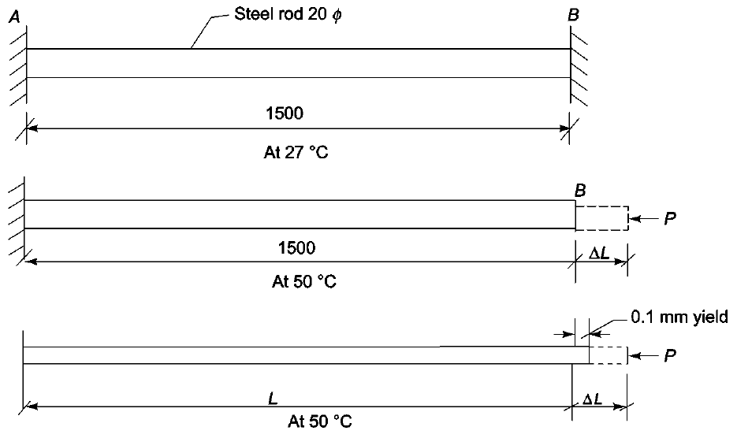  Fig.11b | [5M]
12. | a) | A cantilever of 10m span carries loads of 4kN and 6kN at 2m and 6m respectively from the fixed end along with another load of 6kN at the free end. Draw the shear force and bending moment diagrams.  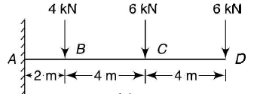  Fig.12a | [5M]
 | b) | Draw SFD and BMD for cantilever beam carrying uniformly varying load.  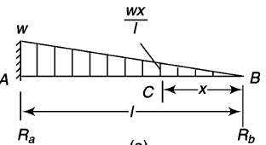  Fig.12b | [5M]
13. | a) | A 2.5m long and 30mm thick tie bar is tapered section. The longitudinal section tapers from a depth of 60mm to 180mm at the ends as shown in fig.13a. A load of 54kN acts through the centroid of the smaller end parallel to top edge. Determine the position and the magnitude of the maximum tensile stress.  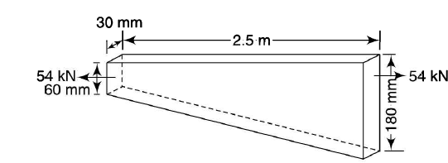  Fig.13a | [5M]
 | b) | Prove the relation σ/y =M/I = E/R for simple bending. | [5M]
14. | a) | Find the deflection under each load and the maximum deflection, E=210 kN/mm² and I = 180X10⁶ mm⁴ for simply supported beam as shown in fig14.a.  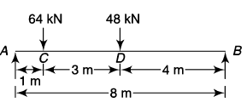  Fig.14a | [5M]
 | b) | State the moment area method. Compare the double integration and moment area methods and state the advantage of each. | [5M]
15. | a) | Derive expression for stress on an inclined plane in a body subjected to a bi-axial stress condition. | [5M]
 | b) | The stress on two mutually perpendicular planes through a point in a body are 120N/mm² and 30N/mm² both tensile along with a shear stress of 60N/mm². Determine i) the magnitude and direction of principle stresses stating whether the stress condition is uniaxial or biaxial, ii) the planes of maximum shear stress, and iii) the normal and shear stress on the planes of maximum shearing stress. | [5M]
16. | a) | Principal stresses at a point in an elastic material are 100N/mm² tensile, 50N/mm² tensile and 25N/mm² compressive. Determine the factor of safety against failure based on various theories. The elastic limit in simple tension is 220N/mm² and passion’s ratio 0.3. | [5M]
 | b) | A simply supported beam of 2m span carries a UDl of 140kN/m over the whole span. The cross-section of the beam is a T-section with a flange width of 120mm, web and flange thickness of 20mm and overall depth of 160mm. Find the maximum shear stress in the beam and shear stress distribution for a section. | [5M]
17. | a) | What is mean by temperature stresses? Explain. | [3M]
 | b) | Draw SFD and BMD for simply supported beam as shown in fig.17.b.  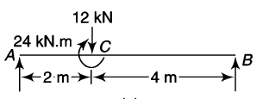  Fig.17.b | [4M]
 | c) | A hollow circular short column of outside diameter 300mm and thickness 10mm carries a load of 1000kN. Find at what eccentricity along a diameter the load can be placed if the permissible stresses are 150N/mm² in compression and 80N/mm² in tension. | [3M]
18. | a) | State and Prove the Maxwell’s reciprocal deflection theorem. | [4M]
 | b) | Derive the expression for principal stress for a body subjected to direct and shear stress. | [3M]
 | c) | What assumptions are taken in the analysis of shear stress in beams? | [3M]

-- 00 -- 00 –

